## Question 1 (3 points max. 150 words):

The question on this page is based on Arenas, A. E., Goh, J. M., & Matthews, B. (2019). Identifying the business model dimensions of data sharing: A value‐based approach. *Journal of the Association for Information Science and Technology*, *70*(10), 1047-1059.

This study aimed to investigate the underlying business model of organizations that have data sharing at the core of their activities. Previous work has stressed that data-sharing projects need to be sustainable in the long term, and highlighted the need for a deeper understanding of the operation model of existing data-sharing initiatives. To investigate this important issue, we took a qualitative approach to uncover the dynamics of value creation in data sharing. Using a case study method, we examined two data-sharing sites across different areas. We conducted semi-structured interviews with managers from data centers and other stakeholders, and reviewed documents about the technical and managerial practices to determine the main characteristics of their business models. In addition, we applied the e3-value modeling methodology to tease out the value flows within each site. Our findings demonstrated the importance of the value network dimension of a business model, as data sharing relies on a set of actors creating and getting value in the process, and the significance of intangible assets. The main contributions of this study include extending current understanding on data-sharing business models by analyzing key dimensions, and uncovering how value is created and transferred in data sharing.

The study of Arenas, Goh & Matthews (2019) aimed to investigate the underlying business  
model of organizations that have data sharing at the core of their activities, using the central research question “How is value created through data sharing?” Discuss at least three criteria that determine why a case study is a suitable method for this research. Mention each criterion AND explain briefly why this criterion is relevant for this specific study (3 points)

1. Case study is typically used for how and why questions where researchers cannot manipulate the core concepts. In this study, it’s aiming at investigating the underlying business model of organizations that have data sharing at the core of their activities. Thus, it focuses on the how and why questions and the existing cases fit their need when they cannot manipulate the concept.
2. Study concerns the contemporary phenomenon. In this study, the underlying business model fits the situation.
3. Many variables of interest. In this study, they find data sharing relies on a set of actors.

## Question 2 (3 points max. 150 words)

The questions on this page are based on Arenas, A. E., Goh, J. M., & Matthews, B. (2019). Identifying the business model dimensions of data sharing: A value‐based approach. *Journal of the Association for Information Science and Technology*, *70*(10), 1047-1059.

Arenas, Goh & Matthews (2019) conducted a qualitative study using a multiple case study approach of two organizations that have data sharing at the core of their activities.

1. Provide one reason why it may be beneficial for this study to adopt a multiple case study approach compared to a single case study approach. (1 point)
2. Discuss two rationales that can be used, in general, for conducting a single case study approach. Do not only mention the rationale, but also explain each rationale. (2 points)
3. To increase the study’s external validity.
4. 1. critical case: it represents an extreme instance that can illuminate or challenge the established theories and assumptions.

2. unique case: in this rationale, unique means that there no any other cases similar to the case, thus we do a single case study.

## Question 3 (2 points max. 100 words)

Qualitative data analysis can sometimes be assessed using ‘interjudge reliability’. Explain (in multiple sentences) what is meant with interjudge reliability. Both give a definition of interjudge reliability AND explain how interjudge reliability can be measured.

Interjudge reliability measures the consistency of judgement across different evaluators/coders, ensuring that the analysis is not dependent on a single individual’ perspectives.

Interjudge reliability can be measured by multiple evaluators independently analyzing the same qualitative data.

## Question 4 (2 points max. 20 words):

Read the following quote, which was taken from an interview with Mark Zuckerberg (October 28, 2021):

“I think it’s really important that the metaverse works for people, not just as consumers, but as creators, and that people economically have a stake in it as well. This is one of the lessons that I’ve taken away from the last five years of some of the issues that we’ve struggled with as well, is that it’s not enough to just build a product that people love. There needs to be an ecosystem that’s built around it where a large number of people have a stake in the success of that thing, and are benefiting not just as consumers, but also economically as it grows in order for it to be a sustainable enterprise in the world at the scale that we’re talking about. For Facebook and Instagram, I think a lot of that has been, there have been creators on the platform, there are advertisers who are part of that, but I think for the metaverse, the creator economy is just going to have to be a very fundamental thing to it. My hope for this is that it’s not just primarily a consumption oriented experience, like what I think the allusion that you were making to Ready Player One, but that this is something that a lot of people, millions of creators and developers will be active participants in and have an active stake in how it gets developed.”

A researcher is interested in wat could be success factors of the metaverse, a network of 3D virtual worlds focused on social connection. She defined a coding category called ‘metaverse success factors’, where success factors refer to factors on which a high score predicts commercial viability. Based on the quote above, suggest two codes that fall within this coding category.

Sustainability; Creativity

Question 1

The questions on this page are based on Liu, A., Gu, J., & Liu, H. (2021). The fit between firm capability and business model for SME growth: a resource orchestration perspective. R&D Management.

Despite the increasing attention on the role of the business model in affecting firm performance, knowledge of how to leverage the influence of business models remains scarce. Drawing on resource orchestration theory, we theorize how firm capabilities, such as technology capability and marketing capability, moderate the relationship between the business model and firm performance in the context of small and medium-sized enterprises (SMEs). Matched survey data and objective performance data were collected from 140 Chinese manufacturing SMEs in two waves to test our model. The results reveal that the interaction of the efficiency-centered business model with technology capability and the interaction of the novelty-centered business model with marketing capability both positively impact SME performance. Theoretical and practical insights on how firm capabilities can leverage the performance impact of business models are discussed.

1. In the conclusions of the paper, the authors mention a practical insight from the study:   
   `When SMEs adopt novelty-centered business models to improve performance, managers should emphasize the development and leverage of marketing capability’  
   A management consultant has read this practical insight. The consultant now starts to wonder how SMEs could increase their marketing capability. Formulate an exploratory research question that addresses his curiosity. Make sure that your research question is **not** descriptive, **not** normative and **not** prescriptive. (2 points)

How can some SMEs succeed in increasing the marketing capability?

Question 2

The questions on this page are based on Liu, A., Gu, J., & Liu, H. (2021). The fit between firm capability and business model for SME growth: a resource orchestration perspective. R&D Management.

Despite the increasing attention on the role of the business model in affecting firm performance, knowledge of how to leverage the influence of business models remains scarce. Drawing on resource orchestration theory, we theorize how firm capabilities, such as technology capability and marketing capability, moderate the relationship between the business model and firm performance in the context of small and medium-sized enterprises (SMEs). Matched survey data and objective performance data were collected from 140 Chinese manufacturing SMEs in two waves to test our model. The results reveal that the interaction of the efficiency-centered business model with technology capability and the interaction of the novelty-centered business model with marketing capability both positively impact SME performance. Theoretical and practical insights on how firm capabilities can leverage the performance impact of business models are discussed.

1. Formulate a moderation hypothesis, based on the abstract. (2 points)

SME performance is related to specific firms’ capacity.

Question 3

The questions on this page are based on Liu, A., Gu, J., & Liu, H. (2021). The fit between firm capability and business model for SME growth: a resource orchestration perspective. R&D Management.

Despite the increasing attention on the role of the business model in affecting firm performance, knowledge of how to leverage the influence of business models remains scarce. Drawing on resource orchestration theory, we theorize how firm capabilities, such as technology capability and marketing capability, moderate the relationship between the business model and firm performance in the context of small and medium-sized enterprises (SMEs). Matched survey data and objective performance data were collected from 140 Chinese manufacturing SMEs in two waves to test our model. The results reveal that the interaction of the efficiency-centered business model with technology capability and the interaction of the novelty-centered business model with marketing capability both positively impact SME performance. Theoretical and practical insights on how firm capabilities can leverage the performance impact of business models are discussed.

1. In the paper, the authors write:

`We collected the research data in two waves. In Wave 1, we invited the entrepreneurs (i.e., CEOs or presidents) and two top managers (marketing managers and R&D managers) from each firm to participate in an online survey. In the survey, questions were asked about business models and capabilities. In Wave 2, we obtained objective firm performance data from the collaborating government agency a year later because this agency collects business data such as the firm’s sales, operating profit, and total assets every year.’

The decision to collect data in two waves can have impact on the causality claims that the authors can make. List the four conditions of causality as taught in class. For each condition, state if the choice to collect data in two waves has an impact (yes/no). If you answer `yes’, then state in one sentence what the impact is. (2 points)

1. The IV and DV should co-vary: Yes. The wave 1 collecting IV (business model and capacity) and the wave 2 collecting DV (the firm’s performance) make the analysis of the covariance.
2. The IV should precede the DV: Yes. “we obtained objective firm performance data from the collaborating government agency **a year later**”
3. No other factor should cause the DV change: No
4. The relation between IV and DV should derive from a logical explanation: No

Question 4

The questions on this page are based on Liu, A., Gu, J., & Liu, H. (2021). The fit between firm capability and business model for SME growth: a resource orchestration perspective. R&D Management.

Despite the increasing attention on the role of the business model in affecting firm performance, knowledge of how to leverage the influence of business models remains scarce. Drawing on resource orchestration theory, we theorize how firm capabilities, such as technology capability and marketing capability, moderate the relationship between the business model and firm performance in the context of small and medium-sized enterprises (SMEs). Matched survey data and objective performance data were collected from 140 Chinese manufacturing SMEs in two waves to test our model. The results reveal that the interaction of the efficiency-centered business model with technology capability and the interaction of the novelty-centered business model with marketing capability both positively impact SME performance. Theoretical and practical insights on how firm capabilities can leverage the performance impact of business models are discussed.

1. One of the constructs examined by Liu et al. (2021) is technology capability. The authors define it as follows: a  
   firm’s capability to invent new technologies or apply them to the new product development (Zhou et al., 2014).

4.a. Fomulate a 5-point Likert scale item to measure the construct. Provide the answer categories (1 point)

4.b. Suggest a way to assess the predictive validity of the construct you defined (1 point)

1. According to your opinion, how strongly do you agree with the statement “the higher firm’s capability to invent new technologies or apply them to the new product development with efficiency-centered business model can increase the firm’s performance”.

Strongly agree, agree, neutral, disagree, strongly disagree

1. Divide the dataset into 8-2, and use the 20% to be the test dataset to test the predictive validity

Question 5

The questions on this page are based on Liu, A., Gu, J., & Liu, H. (2021). The fit between firm capability and business model for SME growth: a resource orchestration perspective. R&D Management.

Despite the increasing attention on the role of the business model in affecting firm performance, knowledge of how to leverage the influence of business models remains scarce. Drawing on resource orchestration theory, we theorize how firm capabilities, such as technology capability and marketing capability, moderate the relationship between the business model and firm performance in the context of small and medium-sized enterprises (SMEs). Matched survey data and objective performance data were collected from 140 Chinese manufacturing SMEs in two waves to test our model. The results reveal that the interaction of the efficiency-centered business model with technology capability and the interaction of the novelty-centered business model with marketing capability both positively impact SME performance. Theoretical and practical insights on how firm capabilities can leverage the performance impact of business models are discussed.

1. About sampling, the authors write ` We collected survey data and objective performance data from SMEs operating in China’s Yangtze River Delta from 2016 to 2017. This area is one of the fastest-growing regions in China, accounting for about 18.5% of the national GDP in 2014 (Wei and Yin, 2021). We collaborated with a local government agency responsible for evaluating firm growth and investigating industry development every year. Through this government agency, we obtained a list of about 1,200 SMEs. To achieve a representative sample, 600 manufacturing SMEs were randomly selected, covering a broad spectrum of industrial activity, including the consumer products, petroleum and chemical, machinery, and electronics industries

5.a. Define the sampling frame (1 point)

5.b. The authors are not clear on what random sampling technique they utilized. Assume that they used stratified sampling. What could be an example of strata? (1 point)

1. China’s Yangtze River Delta area’s manufacturing SMEs
2. The industry type

**Question 1 (total score 8 points)**

Researchers investigated the impact of two personality traits (Assertiveness and Politeness) on the perceived likeability a person (liking). Two (alternative) hypotheses were tested:

*Hypothesis 1*: People high (vs. low) in Assertiveness are more likely to be liked.

*Hypothesis 2*: People high (vs. low) in Politeness are more likely to be liked.

1. On the next page, you find the JASP output of a regression analysis for this study. Do we accept or reject (alternative) *Hypothesis 1*? [open question; **1 point**]. Use the JASP regression output to motivate your answer [open question; **2 points**].

tt

t=5.059, pvalue<0.001

We reject Hypothesis 1: People high (vs. low) in Assertiveness are more likely to be liked. and accept alternative Hypothesis 1

We have t=5.059. the t value is positive as hypothesized.

Also we have p<0.001. the associated p-value is less than 0.05🡪 Halt is significant.

1. Do we accept or reject (alternative) *Hypothesis 2*? [open question; **1 point**] Use the JASP regression output to motivate your answer [open question; **2 points**].

T=0.821, p=0.412

We accept the Hypothesis 2: People high (vs. low) in Politeness are more likely to be liked. And reject the alt Hypothesis 2.

We have the t value = 0.821 as positive as hypothesized.

Also, we have p-value = 0.412. the associated p-value is bigger than 0.05🡪 Halt is not significant.

1. What is a Type I error? How is the Type I error related to hypothesis testing research, in general? [open question; **2 points**].

Type I error is the situation that when we reject the zero hypothesis but in fact it is true.

This is the one well-known decision error a researcher can make in testing of hypotheses. It is caused by the confidence intervals (set at 95% or 99%) that always leave a margin of error (5% or 1%)

**JASP Regression Output for Question 1**

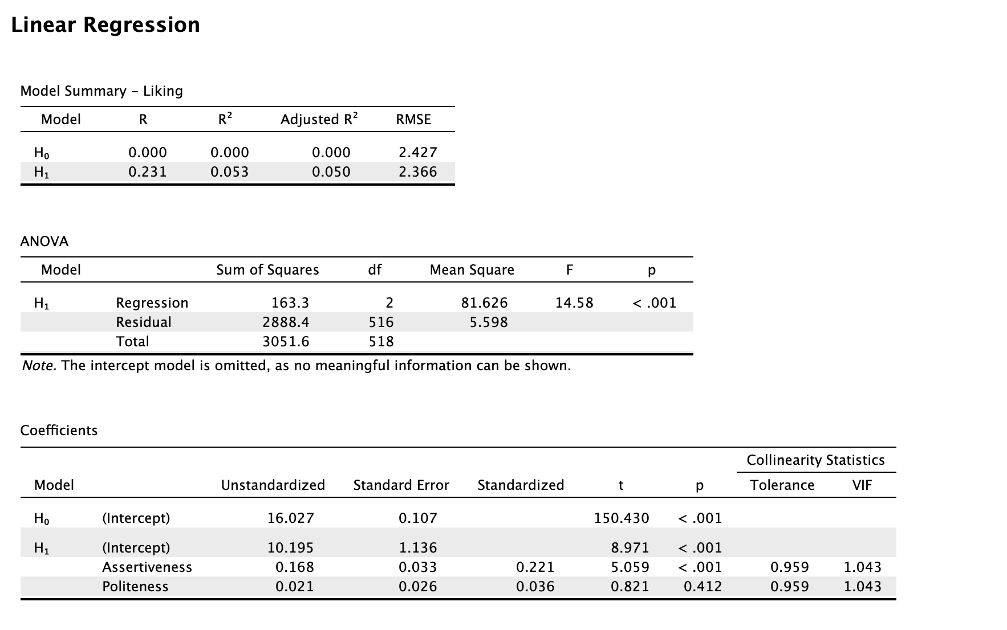

**Question 2 (total of 6 points)**

A correlation analysis of five dimensions of personality (Stretching, Embracing, AltSrch, DecDiff, HghStd), and two types of recommended movie items (known, unknown) yields the following JASP output.

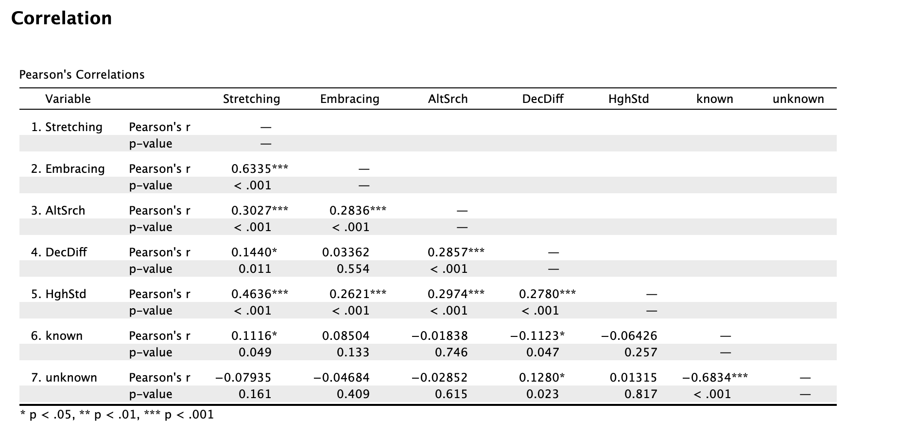

1. How many strong bivariate correlations are summarized in the table, and why? Identify the pairs [open question; **2.0 points**].

Correlations between [0.7, 1] are strong.

So none of them are strong bivariate correlations.

1. What is your assessment of the bivariate relationship between the variables “Embracing” and “known” in the JASP output? What is your conclusion on the relationship? Motivate your answer [open question; **2.0 points**].

The correlation of “Embracing” and “known” is 0.08504. it’s positive which means when one of them grows the other has the trend to grow, but because it’s close to 0, the trend is not that big. Also, p-value=0.133 and the associated p-value is bigger than 0.05 which means it is not significant. So they do not correalted.

1. Kendall’s tau-b is an alternative correlation coefficient. Please describe this alternative correlation coefficient, and explain under what conditions a researcher should use it? [open question; **2.0 points**].

Kendall’s tau b is used for ordinal variables/ ranks.

It is used for small data with a large number of tied ranks which means many scores have the same rank.

**Question 3 (total of 8 points)**

A descriptive analysis of three personality dimensions (SWLS, BSCS, Grit) yields the following JASP output.

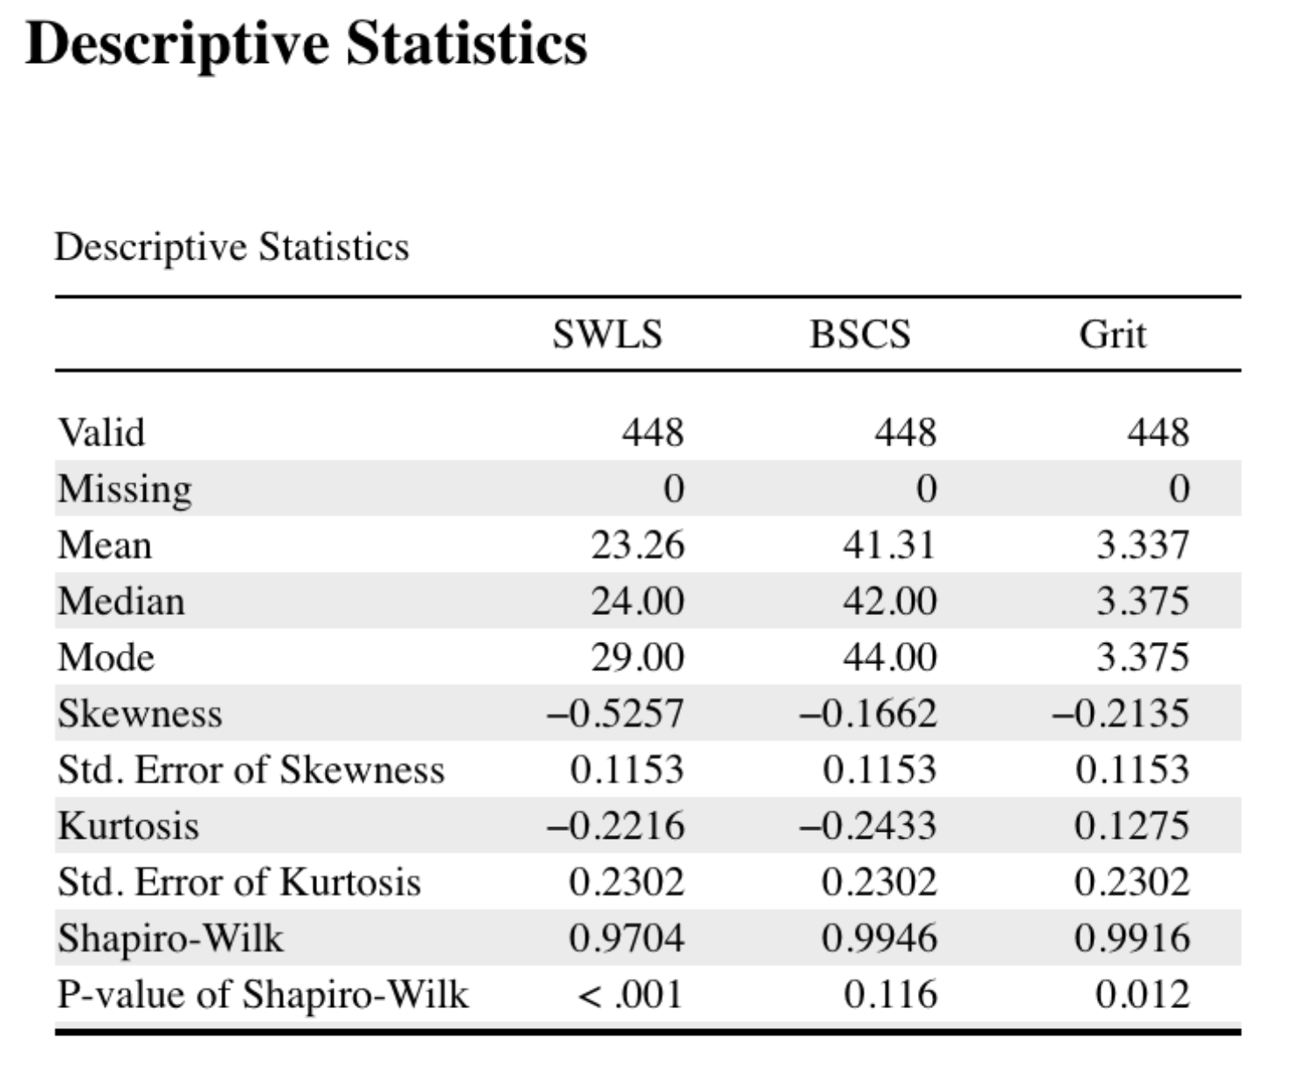

1. What is your formal interpretation of the Shapiro-Wilk test for the BSCS and the Grit variables summarized in the JASP output? [open question; **2.0 points**].

BSCS: SW = 0.9946, p-value=0.116

The associated p-value is bigger than 0.05 which means it is not significant.

So we accept the zero hypothesis that BSCS is normal distributed.

Grit: SW = 0.9916, p-value=0.012

The associated p-value is smaller than 0.05 which means it is significant.

So we reject the zero hypothesis and accept that Grit is not normal distributed.

1. Theoretically, what are the documented weaknesses of the Shapiro-Wilk test? What does this lead you to conclude on the results of this test for the BSCS and the Grit variables summarized in the JASP output? [open question; **2.0 points**].

When the dataset is not large , the result can be problematic, which means for small groups the SW test for normality can be not so trusted.

We can, therefore, never be sure that the result is true.

1. If you look at the values of the mean, mode, and median in the JASP output only, what can you say about the nature of skew of the SWLS variable in this study? Please clarify your answer by adding a drawing on how the distribution of the SWLS variable probably looks like [open question; **2.0 points**].

懒得写了

It is a negatively skewed distribution.

1. Theoretically, what does the notion of kurtosis refer to? Mention two (2) types of kurtosis, which may occur in a dataset, in general [open question; **2.0 points**].

Kurtosis: how flat or peaked a normal distribution is.

1. Mesokurtic: adjusted kurtosis=0 which means it is normal distributed
2. Leptokurtic: adjusted kurtosis>0 which means it has a higher peak.
3. Platykurtic: adjusted kurtosis<0 which means it has a flatter peak.

**Question 4 (total of 8 points)**

Below you find a brief description of a journal article by:

Palloni, A., McEniry, M., Huangfu, Y., & Beltran-Sanchez, H. (2020). Impacts of the 1918s flu on survivors’ nutritional status. *PLoS ONE, 15*, e0232805.

Brief description:

“In this paper we assess the 1918-flu long-term effects on nutritional status during infancy and early childhood. A unique set of events that took place in Puerto Rico during 1918-1919 generated conditions of a “______________ experiment”. We exploit these conditions to empirically identify effects of exposure to the 1918 flue pandemic and those of the devastation left by an earthquake-tsunami that struck the island in 1918. Because the earthquake-tsunami affected mostly the Western coast of the island, whereas early exposure to the flu was restricted to those born in the interval 1917-1920, we use geographic variation as a proxy of earthquake severity as well as of exposure. We use timing of birth variation to identify flu severity as well as of exposure. We benefit from availability of information on markers of nutritional status in a nationally representative sample of individuals aged 75 and older in 2002.”

1. What type of experiment did the authors probably conduct? Motivate your answer [open question; **2.0 points**]?

Quasi

The experiment that compares naturally occurring groups which arose due to a unique set of events that took place in Puerto Rico during 1918-1919 with each other on variables of interest.

1. Which factor probably was the dependent variable under study, and why? [open question; **1.0 point**]?

DV: nutritional status

“we assess the 1918-flu long-term effects on nutritional status during infancy and early childhood”

1. Which factor(s) probably was/were the independent variable(s) under study? [open question; **3.0 points**]?

IV: early exposure to the flu; geographic variation; timing of birth variation;

1. How would you assess the internal validity of this experiment, from a methodological point of view? Motivate your answer [open question; **2.0 points**]?

The internal validity is not high.

As for a experiment (randomized + experimental + control group design). This is, because the researchers did not have control over their experimental groups , they are spilt based on natural events beyond researchers’ control.